Practical-3
Practical Title: Responsive UI Design using CSS Grid, Flexbox, and Bootstrap/Tailwind
Problem Definition Design responsive layouts for Home, About, Registration, Dashboard, and Events pages using CSS Grid and Flexbox. Optional to use CSS framework such as Bootstrap or Tailwind. Ensure mobile-first responsiveness.

A.Theory:
1. How does the layout adapt for mobile, tablet, and desktop screens?
Answer: By using Responsive web design (RWD) which is a web design approach to make web pages render well on all screen sizes and resolutions while ensuring good usability. It is the way to design for a multi-device web.
Source: MDN Web Development

2. Which layout technique is used and why?
Answer: By using CSS Flexbox and Grid Layout.
Source: MDN Web Development
3. Are typography, spacing, colors, and contrast readable?
Answer: Yes ,Everything is made good that user can easily interact .
Source:Geeksforgeeks
4. Is the framework used consistently without unnecessary inline CSS?
Answer: Frameworks like Tailwind or Bootstrap use predefined classes consistently. Inline styles are avoided. They break framework consistency and make maintenance difficult.
Source: MDN

B.Implementation/ Output/Result

In this practical, I applied CSS3 and how it helps style and layout web pages. I explored media queries, which let the page change its layout or styling based on screen size, making the website responsive across different devices like mobiles, tablets, and desktops. I also learned about Flexbox, which makes it easier to align and arrange elements in a row or column without using complicated positioning tricks. Along the way, I used common CSS properties like text-align to align text content and display to control how elements are shown on the page (like block, inline, or flex). Overall, this practical helped me understand how responsive design works and how CSS can be used to make a website look good and function properly on any screen size.

C.Evidence Of Work(Screenshots):
1)Home Page:
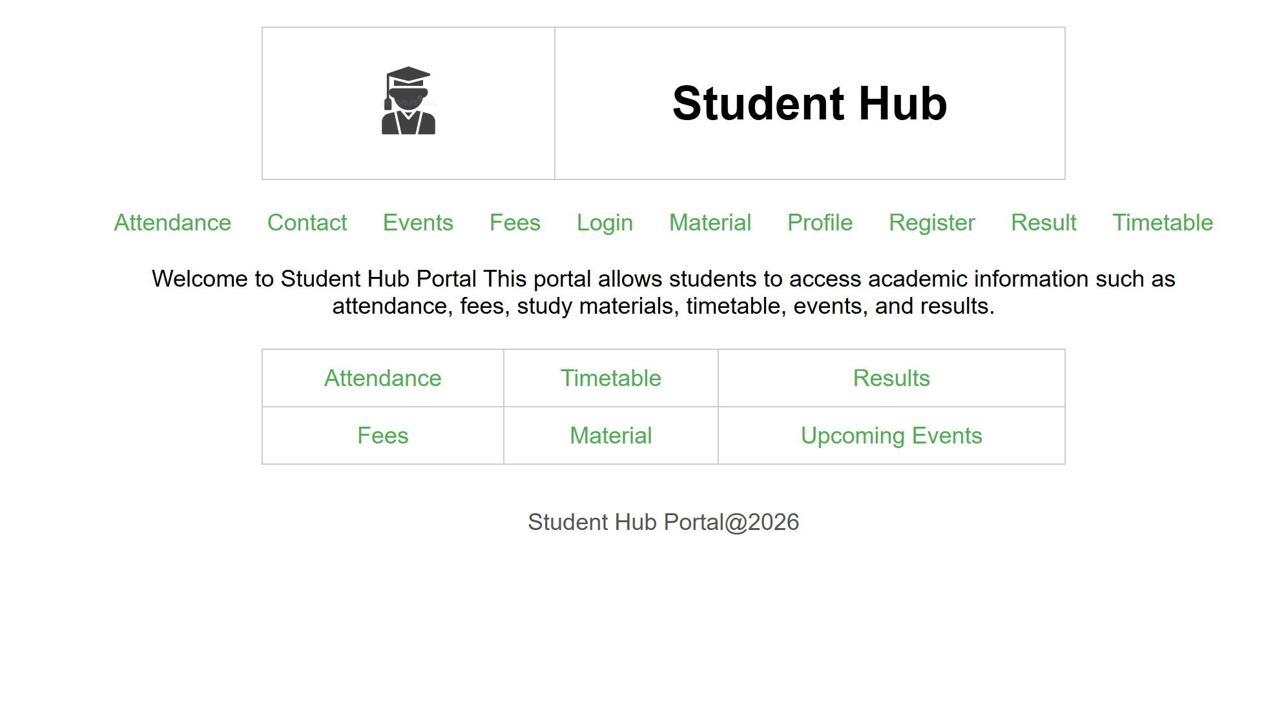

2)Login Page:
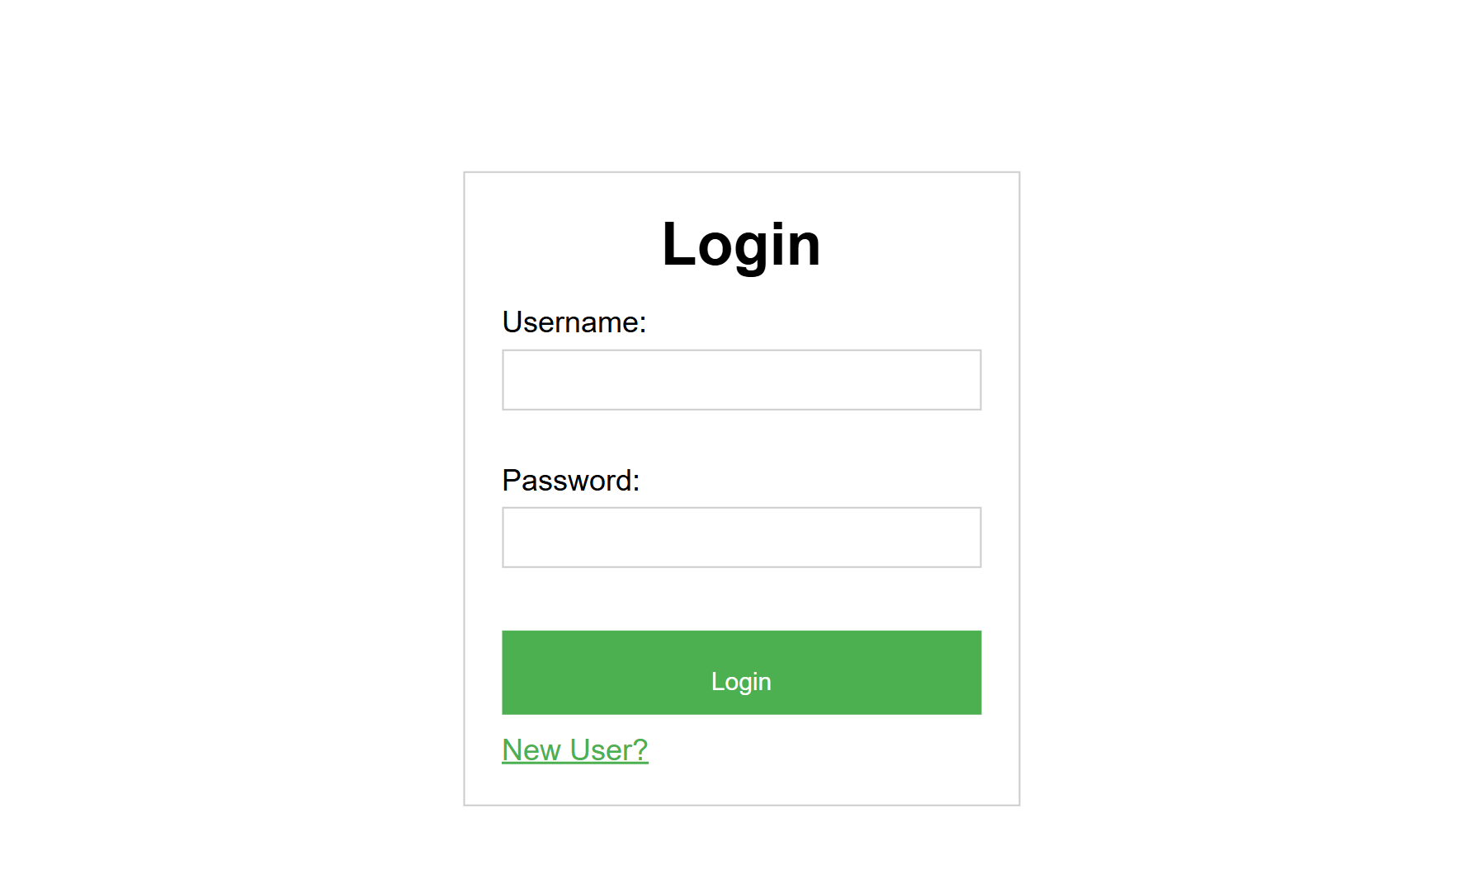
3)Register Page:
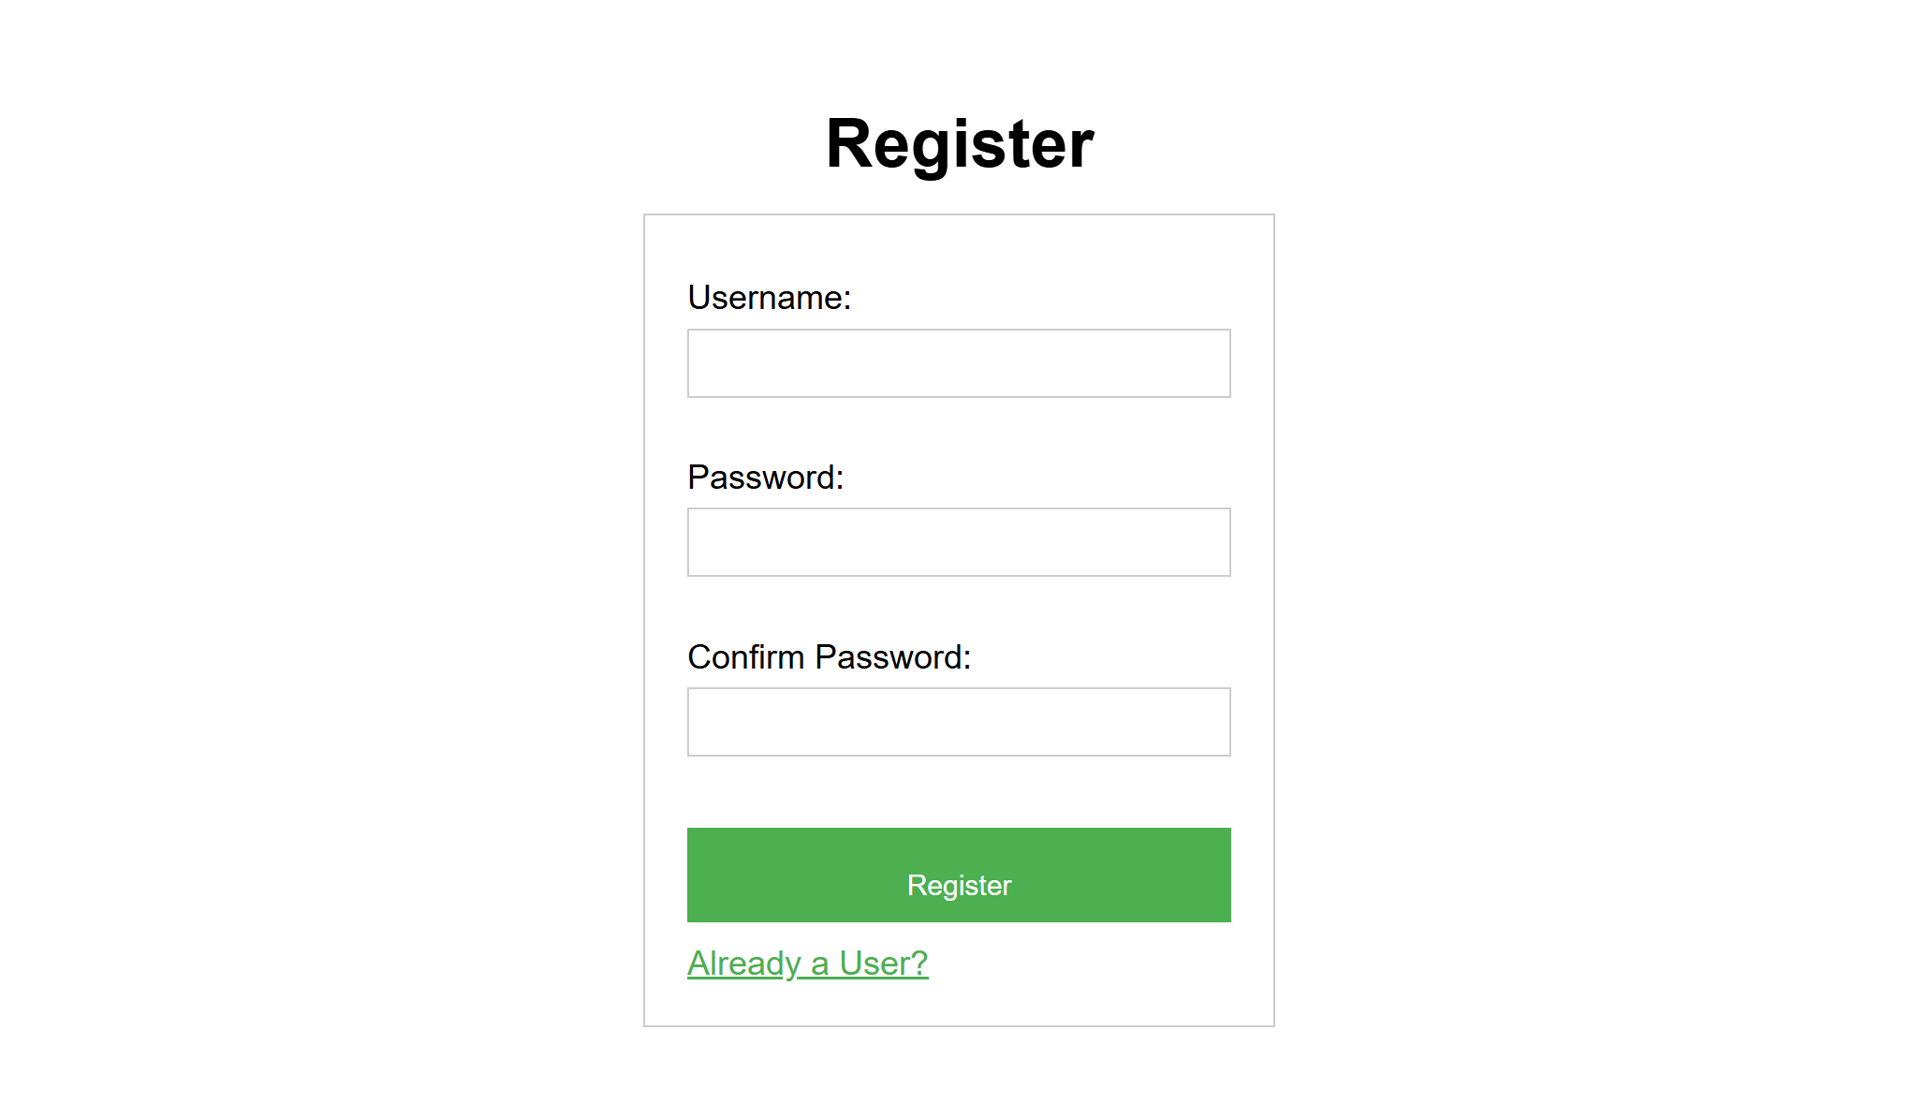

4)Attendance Page:
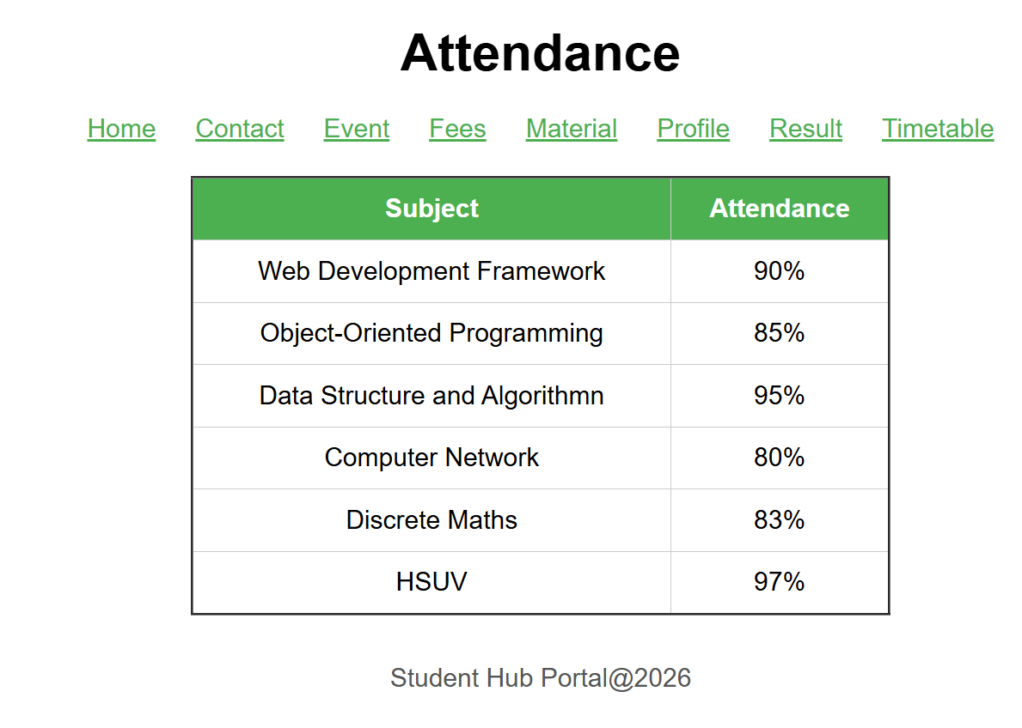
5)Contact Page:
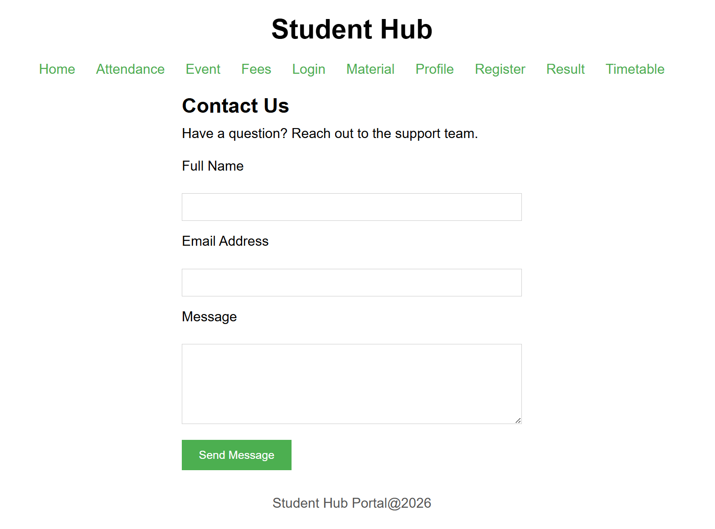

6)Details(Event) Page:
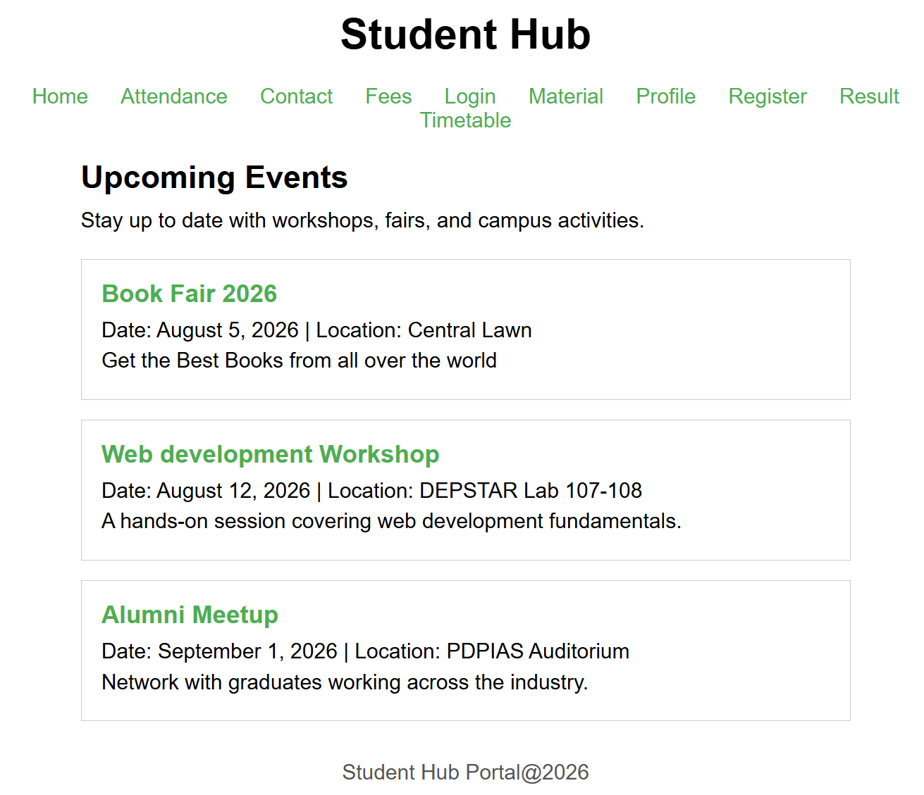
7)Fees Page:
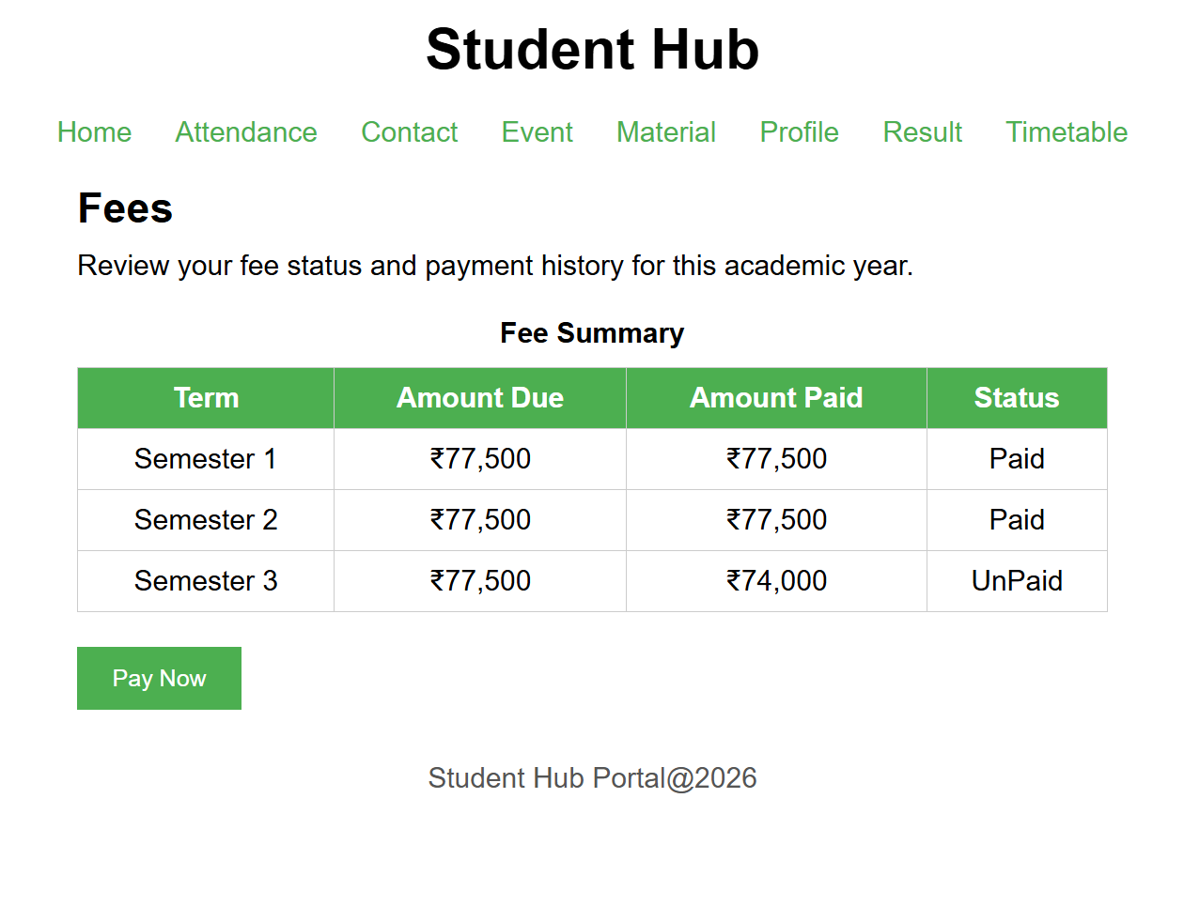
8)Material Page:
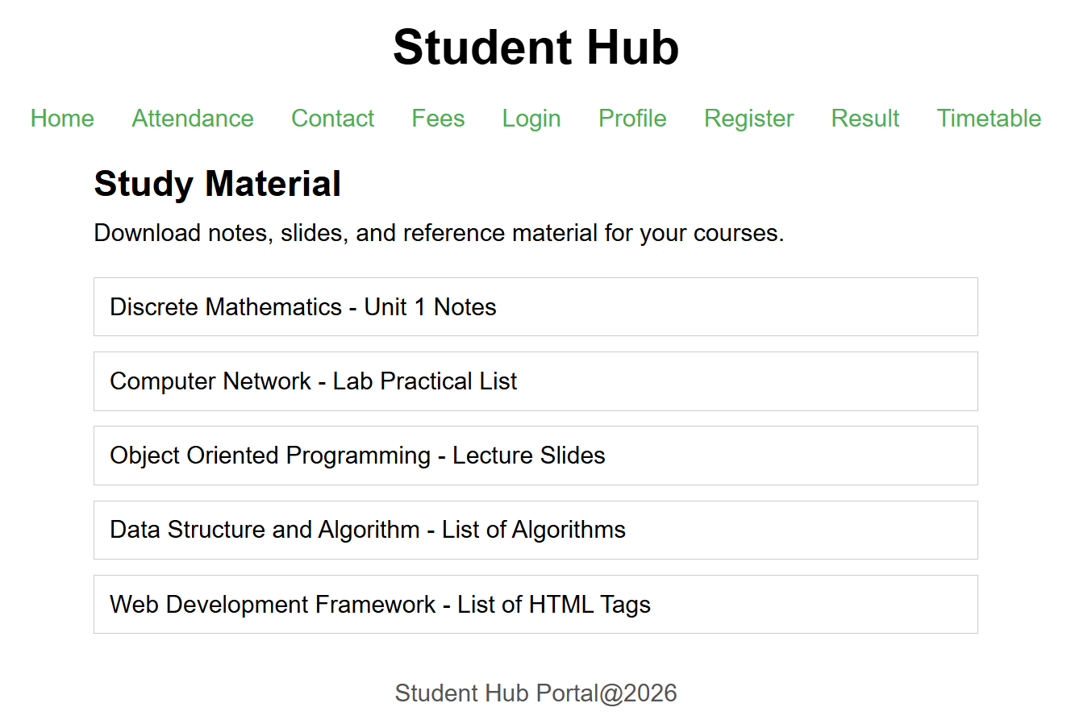
9)Profile Page:

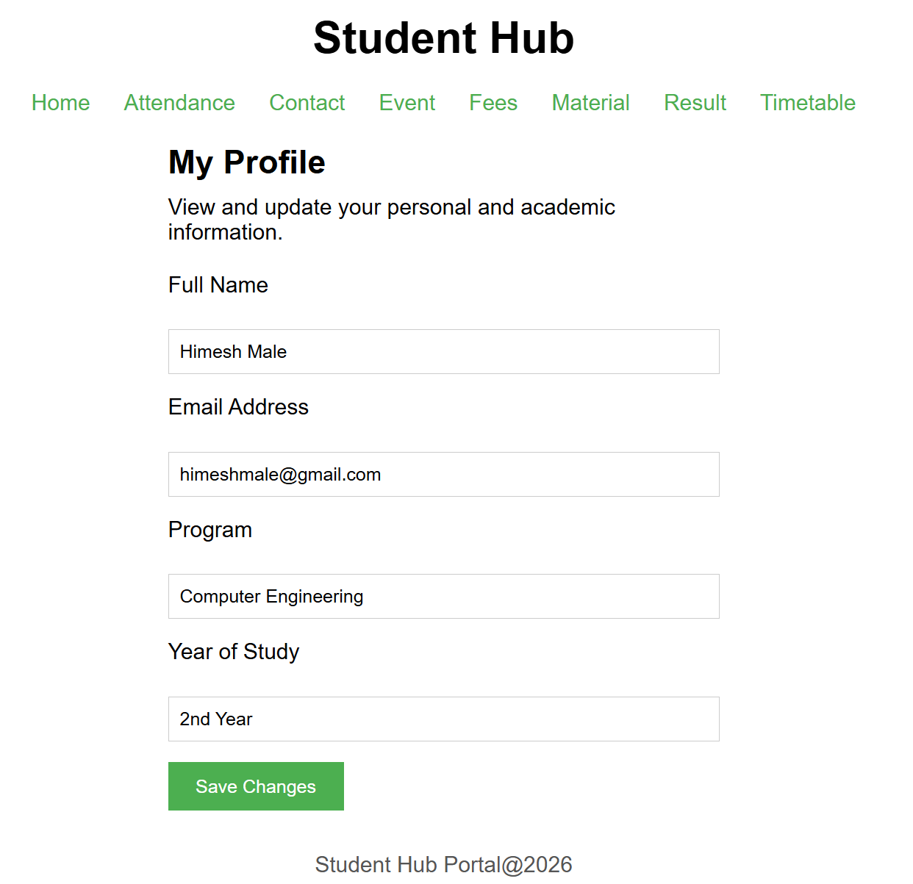

10)Timetable Page:
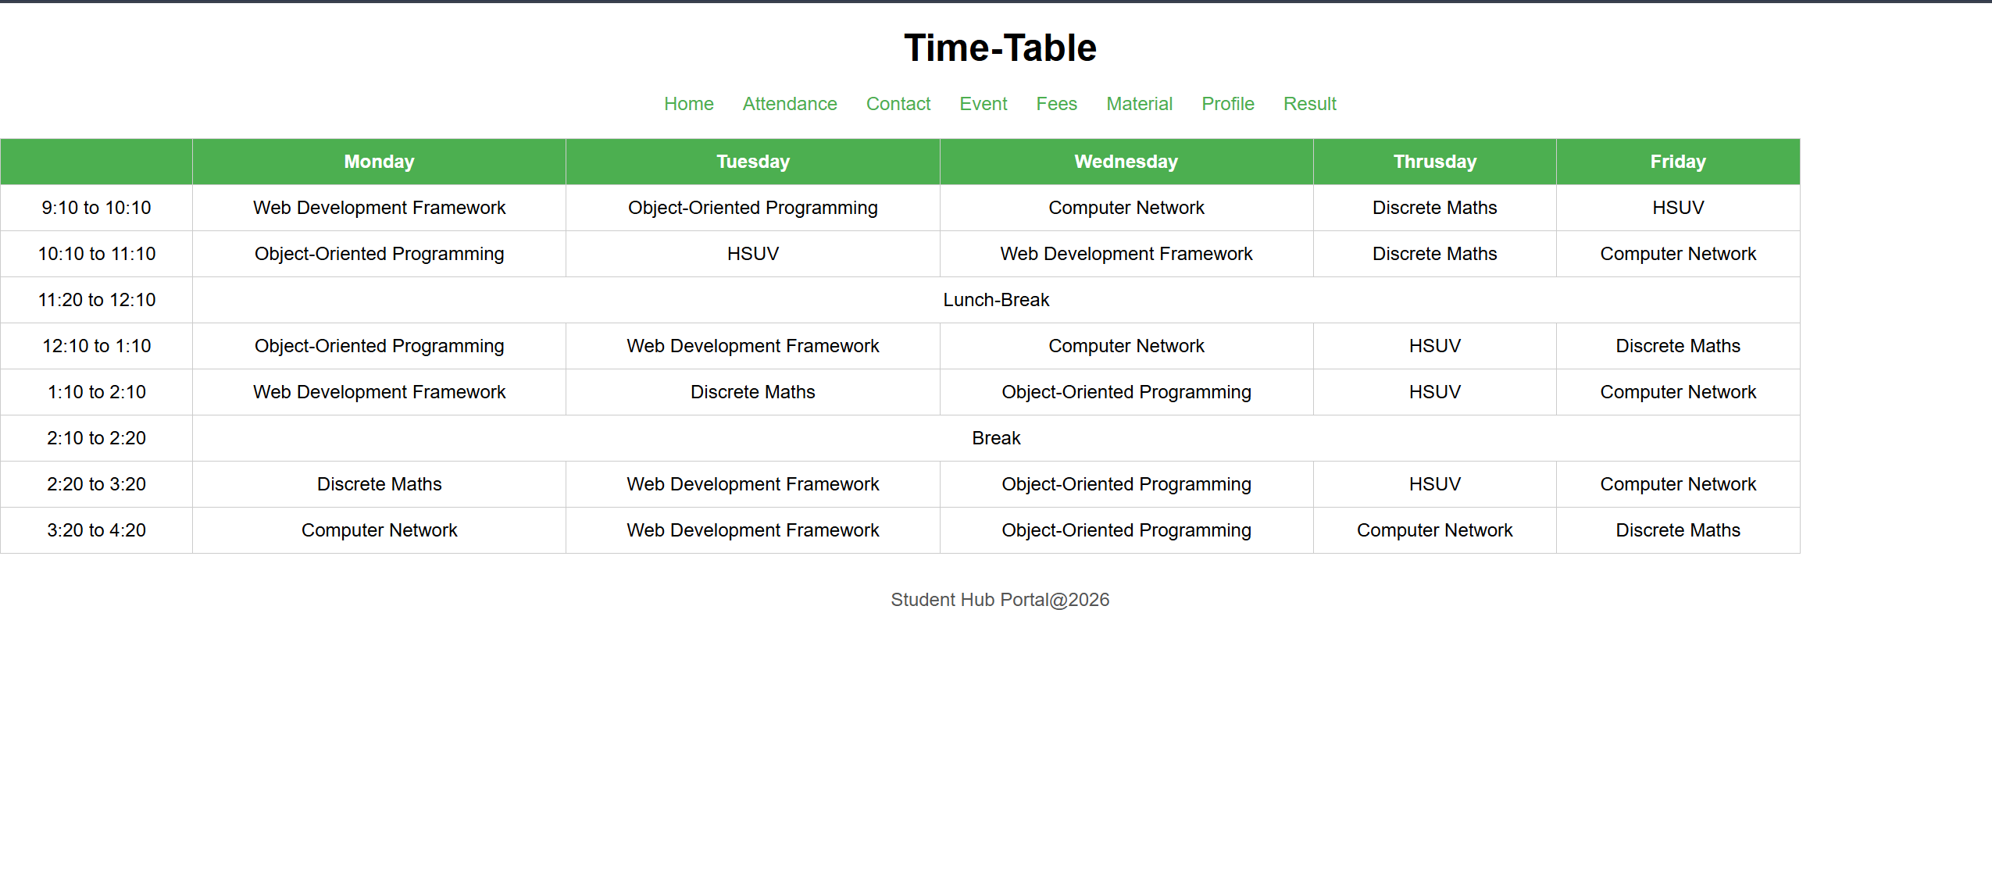

11)Result Page:
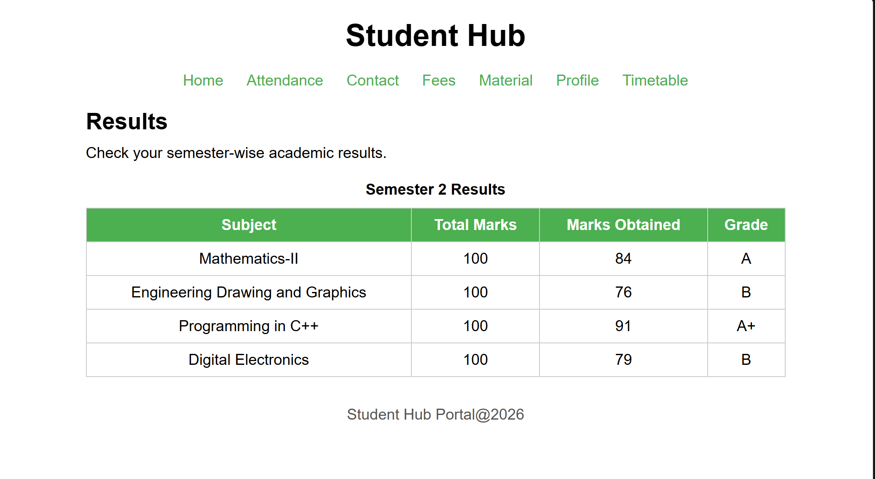

D. GitHub Repository Link: https://github.com/HimeshMale/Student-Hub-Portal.git

E. Challenge Faced:
I found it challenging to get the layout to adjust smoothly across different screen sizes without elements overlapping or misaligning, especially when using Flexbox for navigation and card sections. Managing spacing properly using margin and padding without disturbing the overall layout was another struggle. Keeping the design visually balanced across all pages also took a few attempts.
F. Learning Outcomes:
I learnt how to use Flexbox to align and arrange elements like navbars, buttons, and cards in a clean and responsive manner. I also understood how proper use of margin, padding, and spacing improves the readability and overall look of a page. Additionally, I got a better understanding of maintaining visual consistency across multiple pages.
Faculty Remarks:

